DSA Lab 1 (second)
Muhammad Qasim
Muhammad Qasim
[Company name] [Company address]

Question 1:

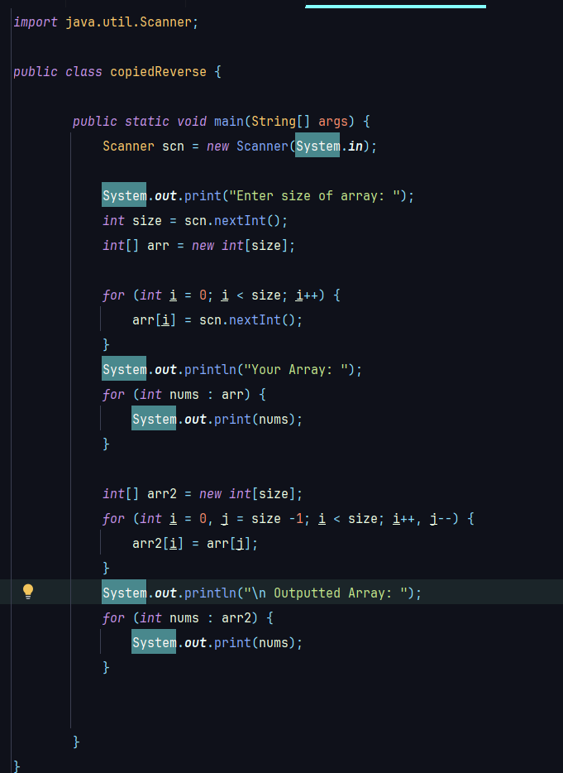
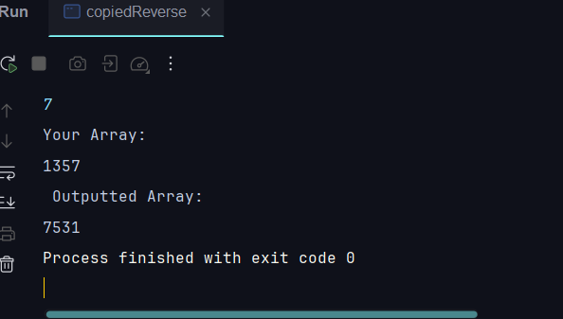
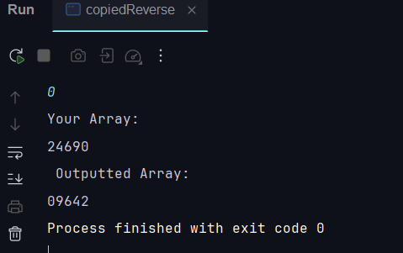

Question 2:
package Test;
import java.util.Scanner;
public class mergerUnsorted {
public static void main(String[] args) {
Scanner scn = new Scanner(System.in);
System.out.println("\nEnter size and elements of first Array: ");
int size1 = scn.nextInt();
int[] arr1 = new int[size1];
for (int i = 0; i < size1; i++) {
arr1[i] = scn.nextInt();
}
System.out.println("\nEnter size and elements of second Array: ");
int size2 = scn.nextInt();
int[] arr2 = new int[size2];
for (int i = 0; i < size2; i++) {
arr2[i] = scn.nextInt();
}
for (int x : arr1) {
System.out.println("\n " + x);
}
for (int x : arr2) {
System.out.println("\n " + x);
}
// int size3 = size1 + size2;
int[] arr3 = new int[arr1.length + arr2.length];
int i = 0;
while(i < arr3.length) {
if (i < size1) {
arr3[i] = arr1[i];
} else {
arr3[i] = arr2[i - size1];
}
}
for (int x : arr3) {
System.out.println("\n " + x);
}
}
}
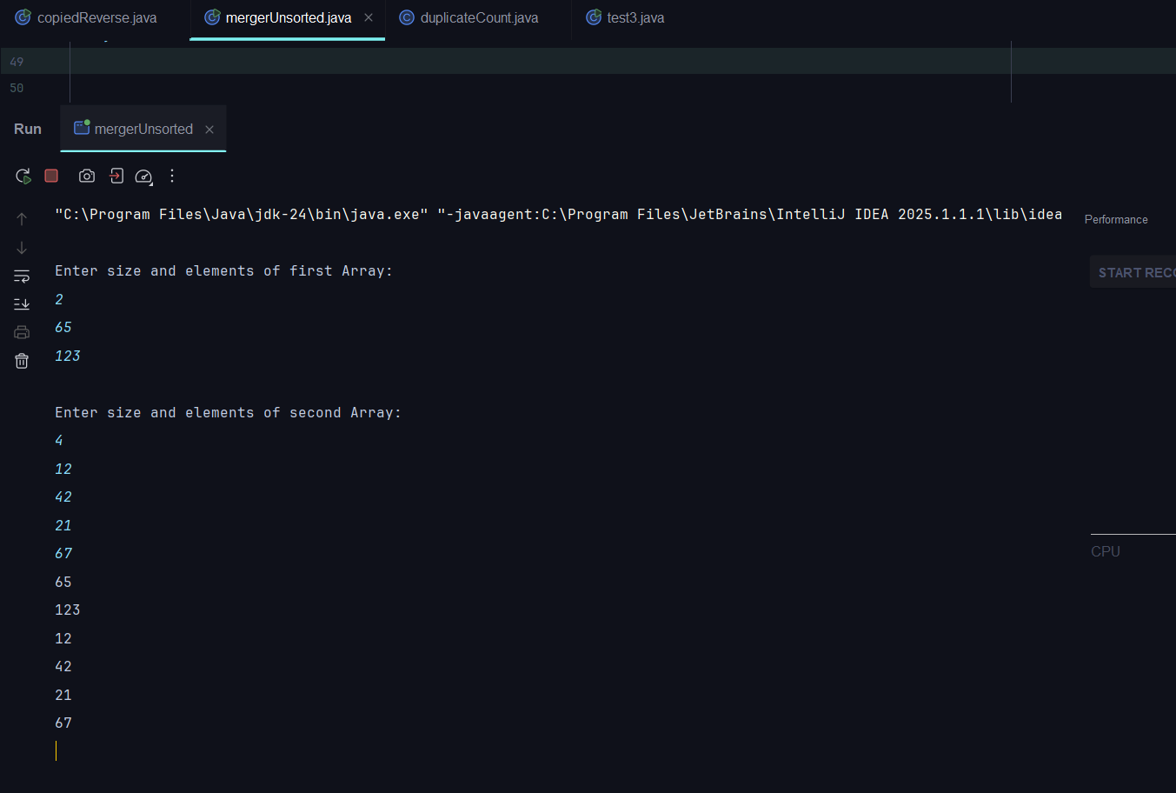// Sorry for Vertical output
Question 3:
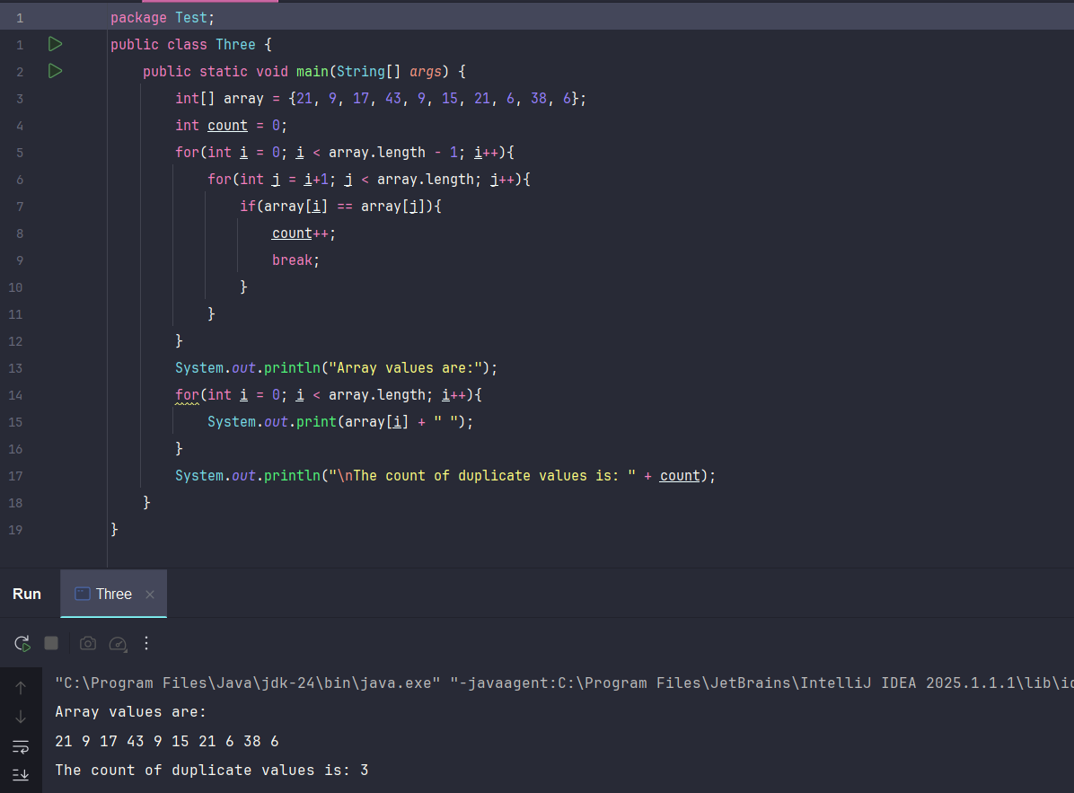
Question 4:
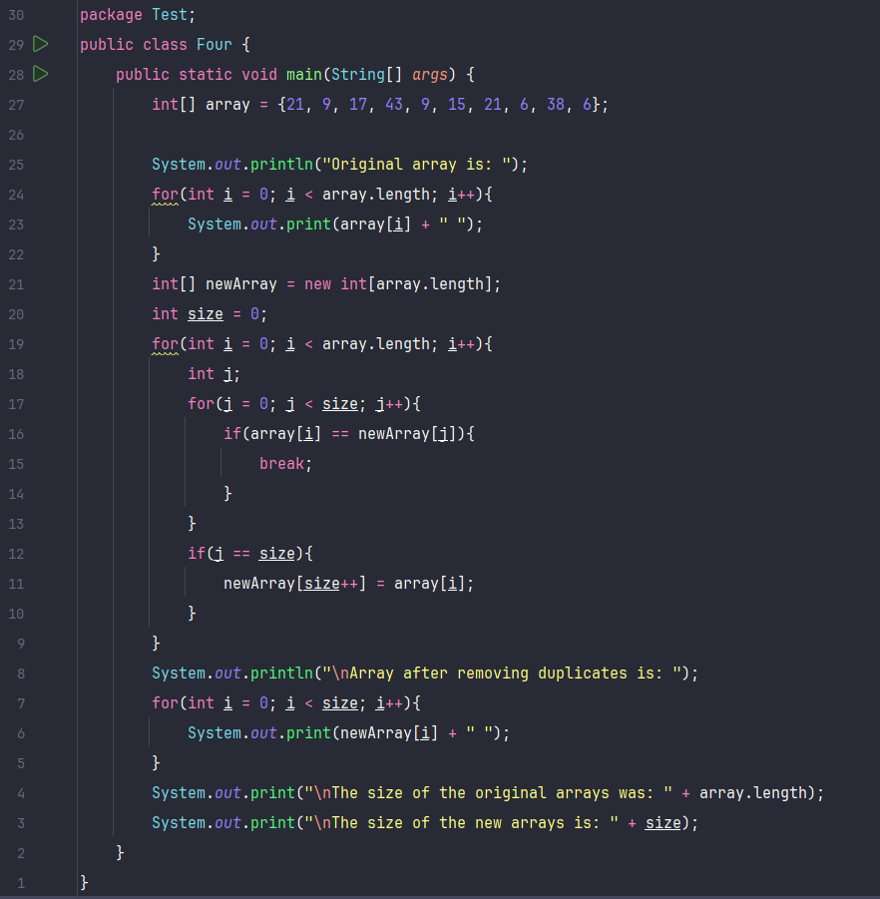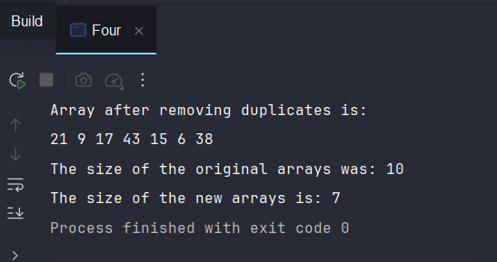
Question 5:
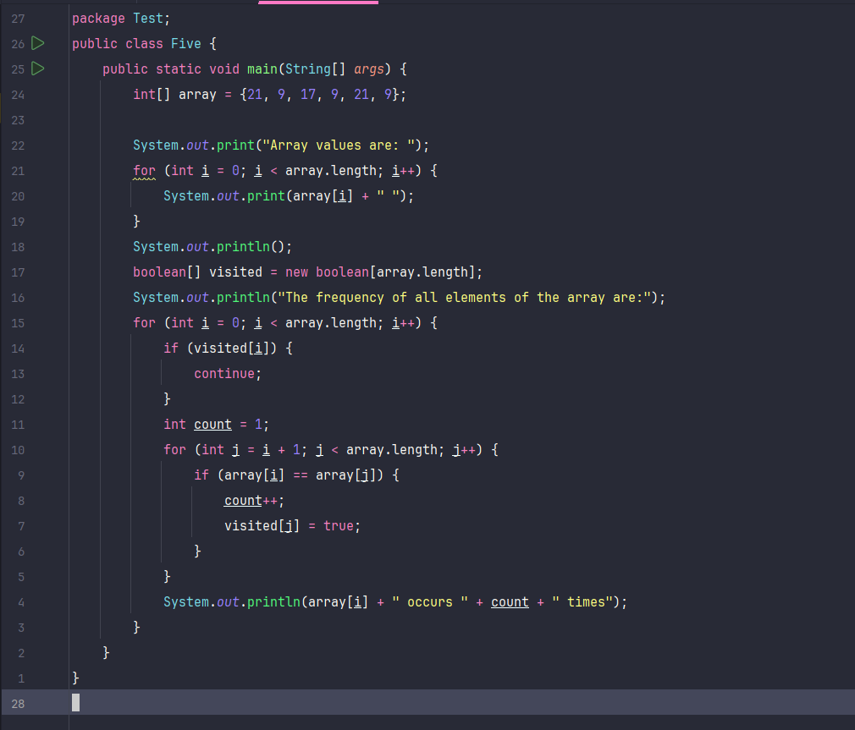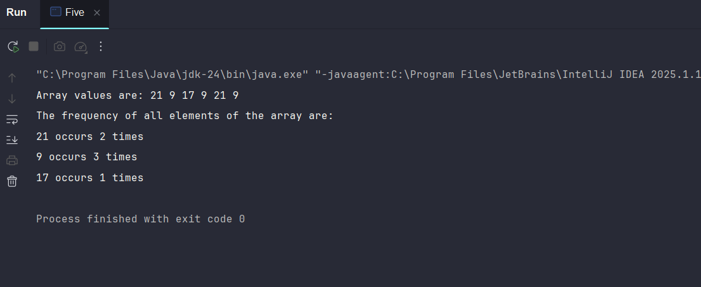

Question 6:
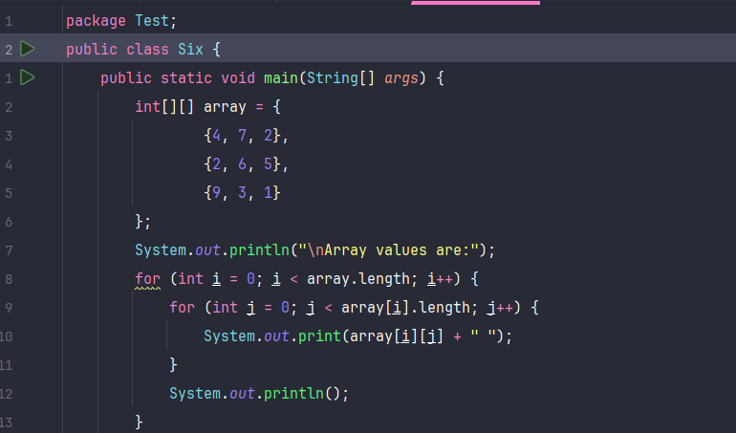
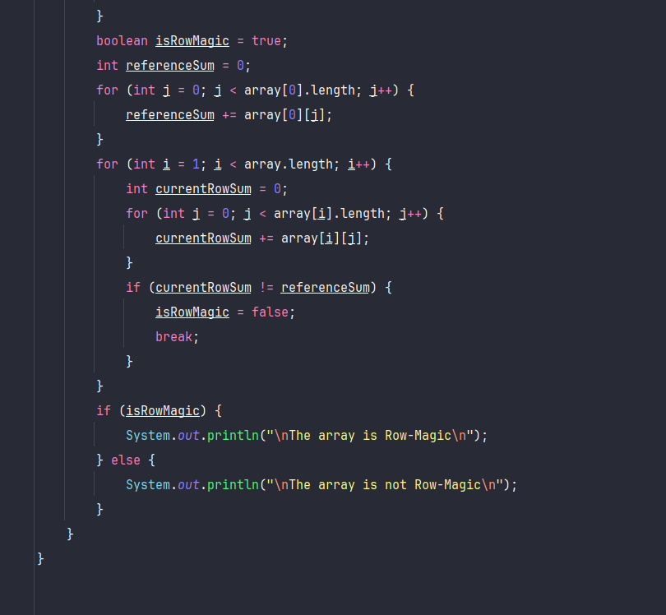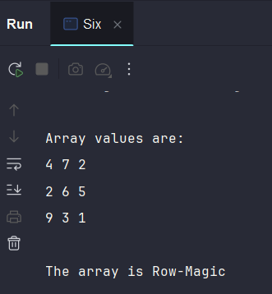

Question 7:
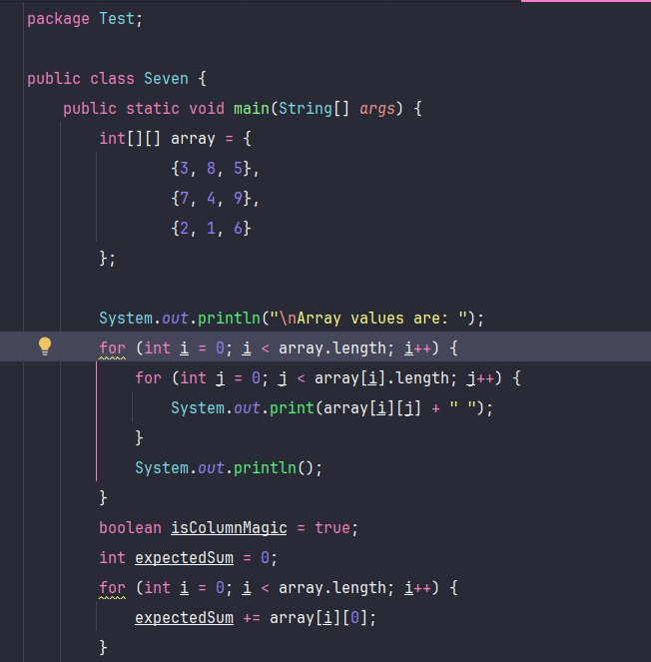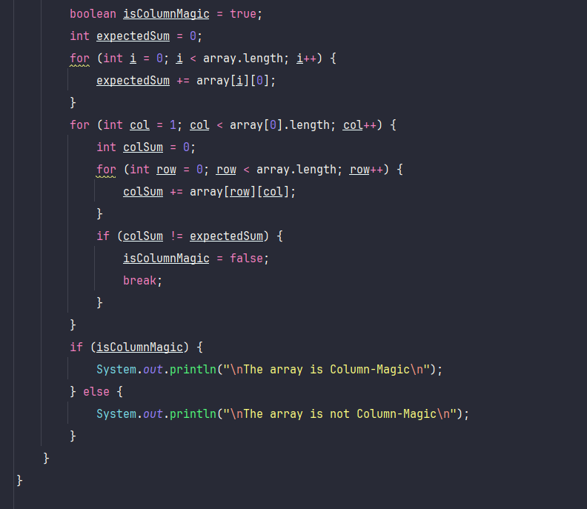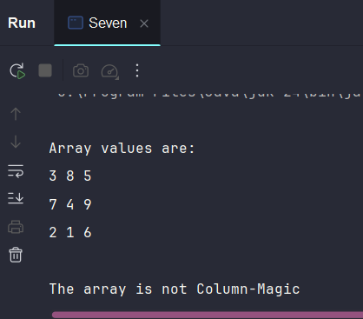
Question 8:

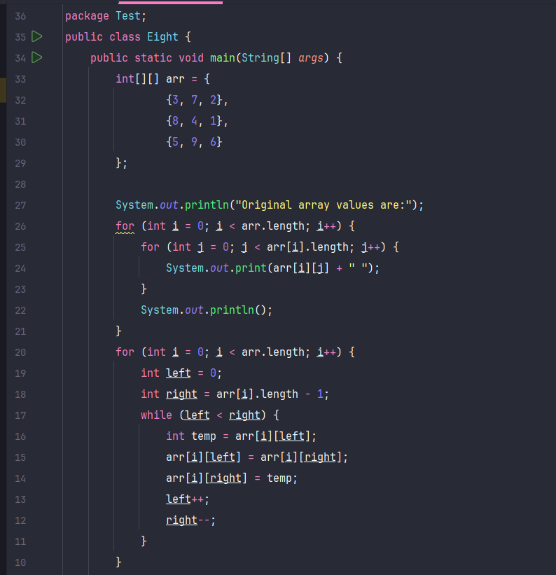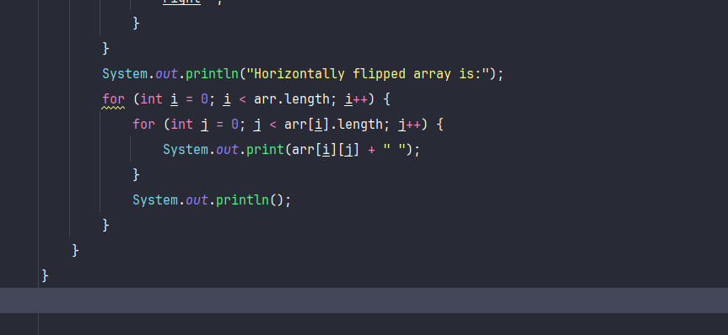
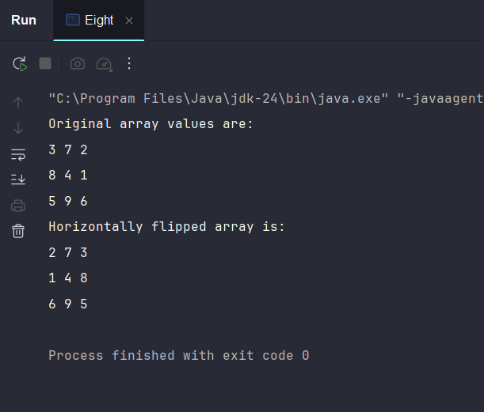

Question 9:
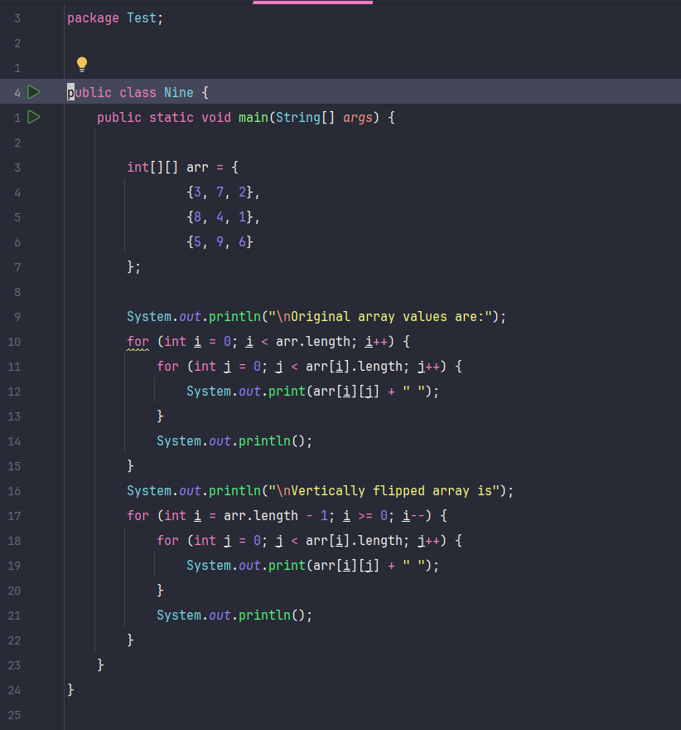
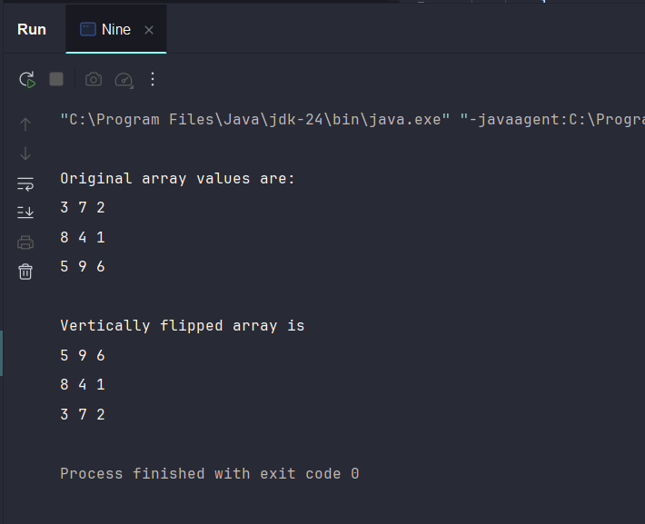

Question 1

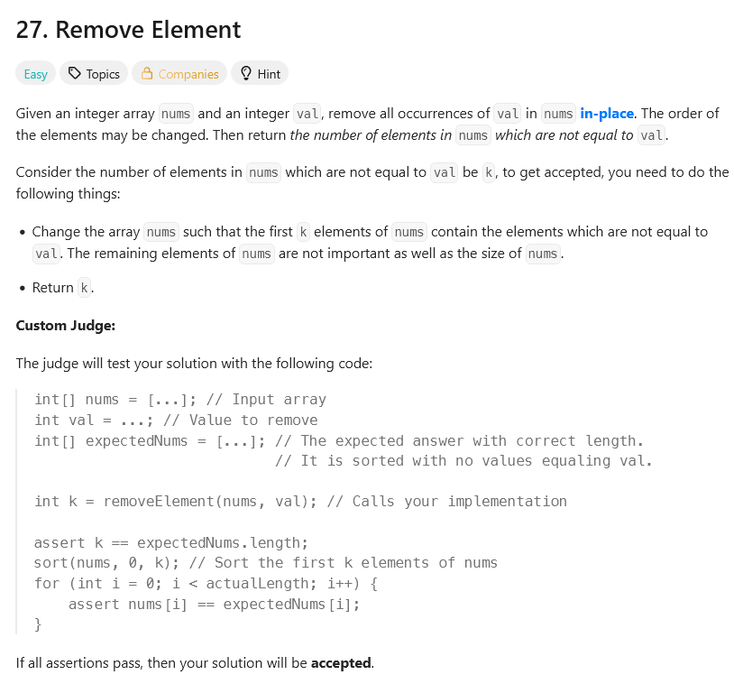
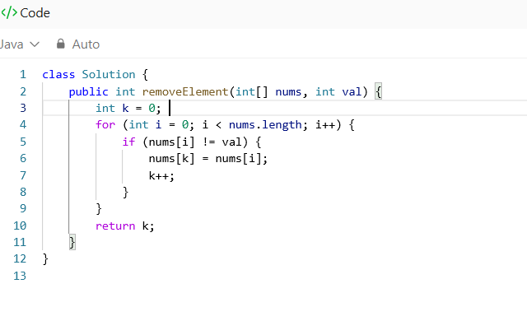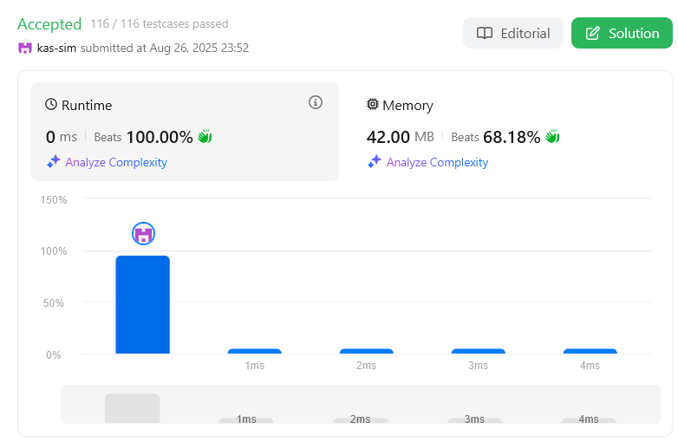

Question 2
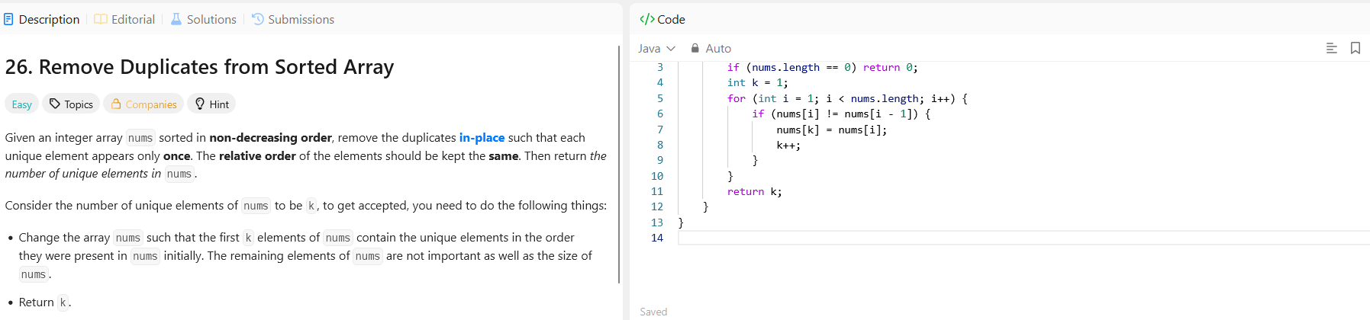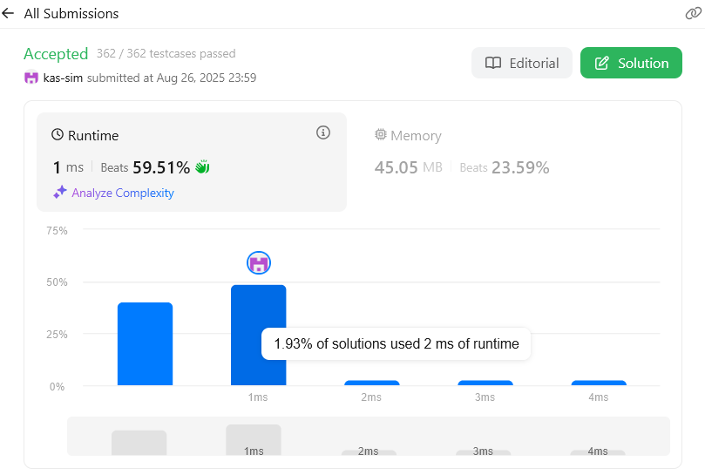

Question 3
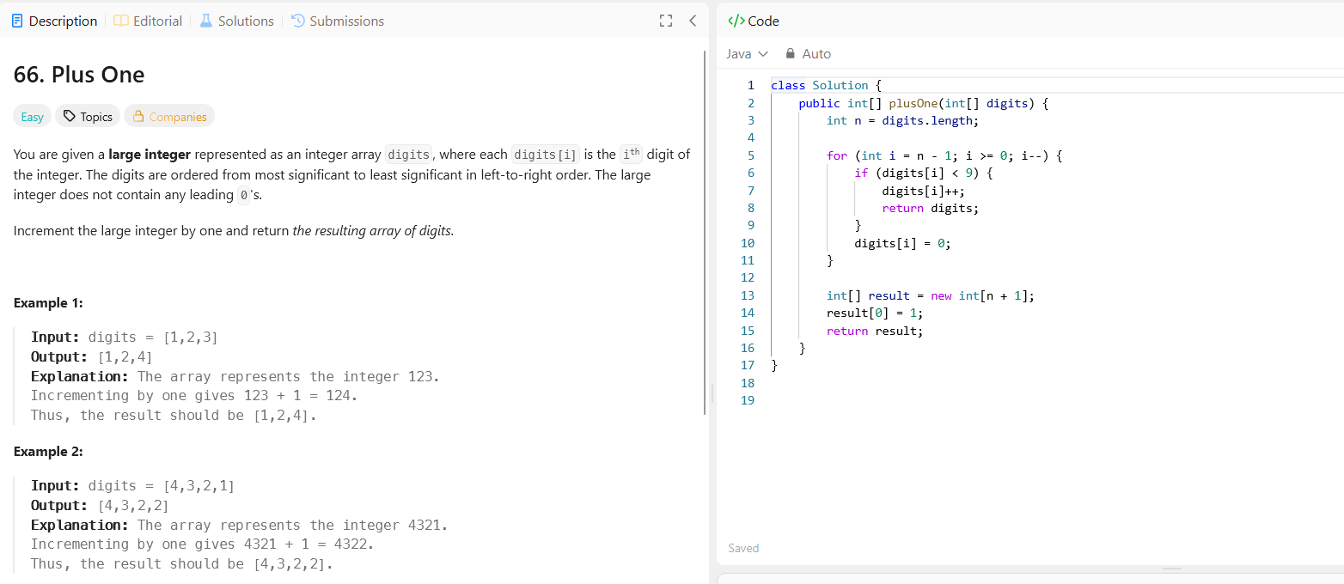
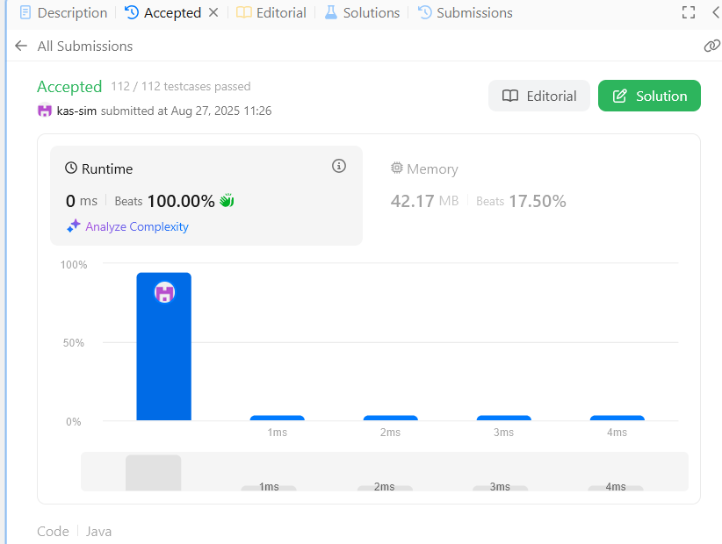

Question 4
